A000-MEX-Colima-Comala-Hairless Dog-Terracotta-Red Glaze-100-900 CE

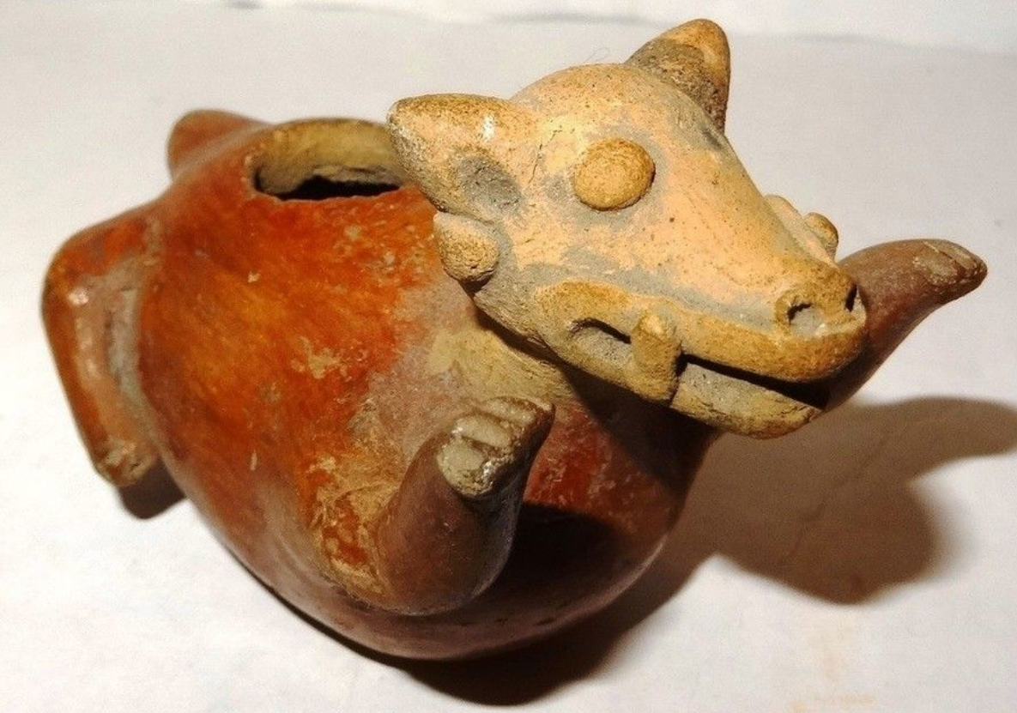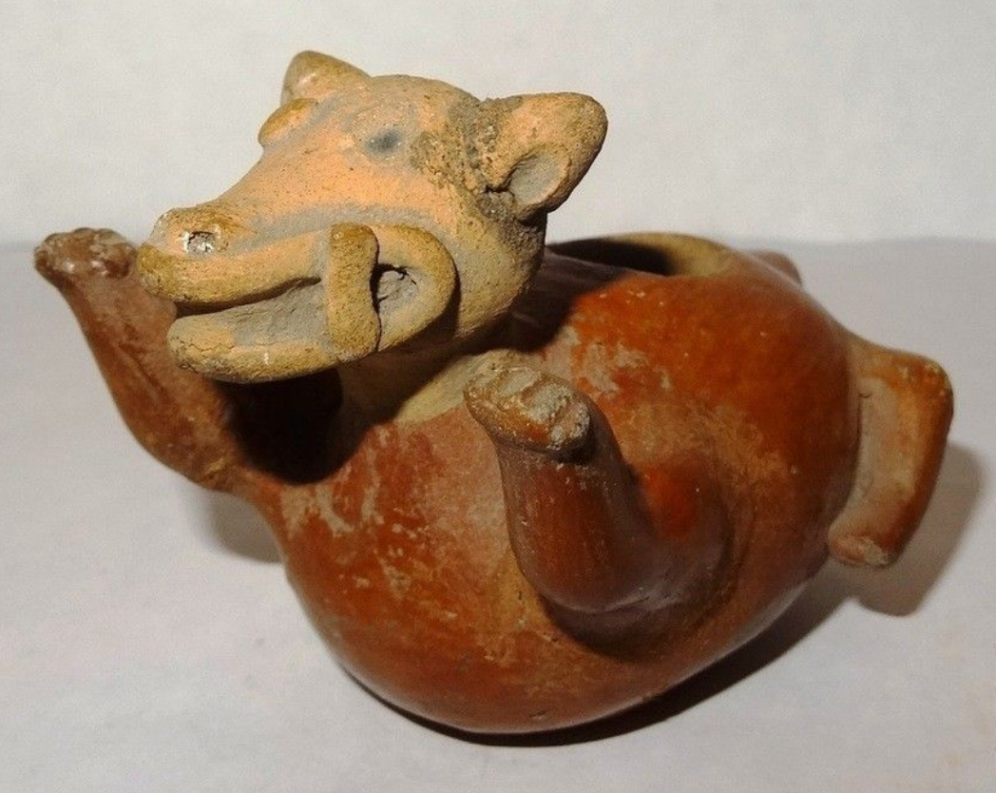

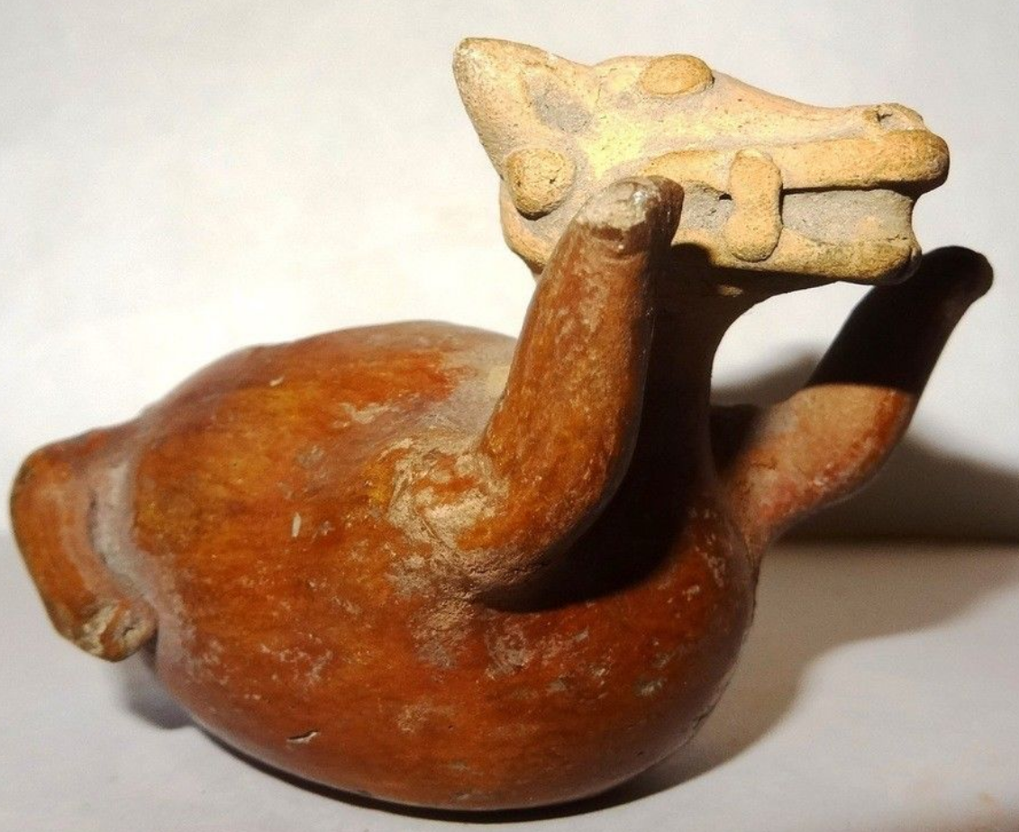 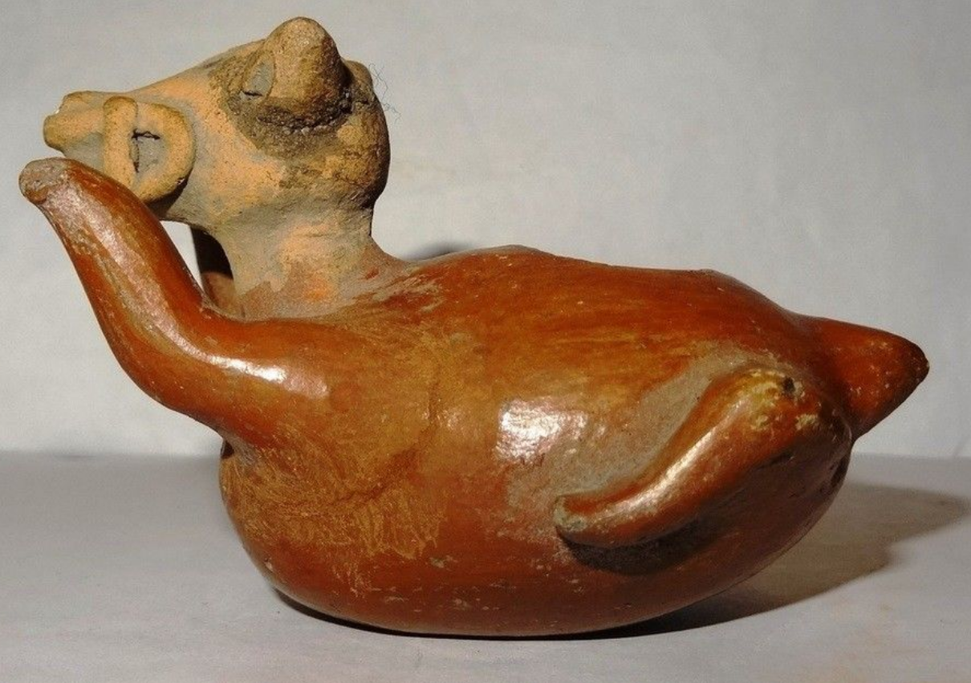

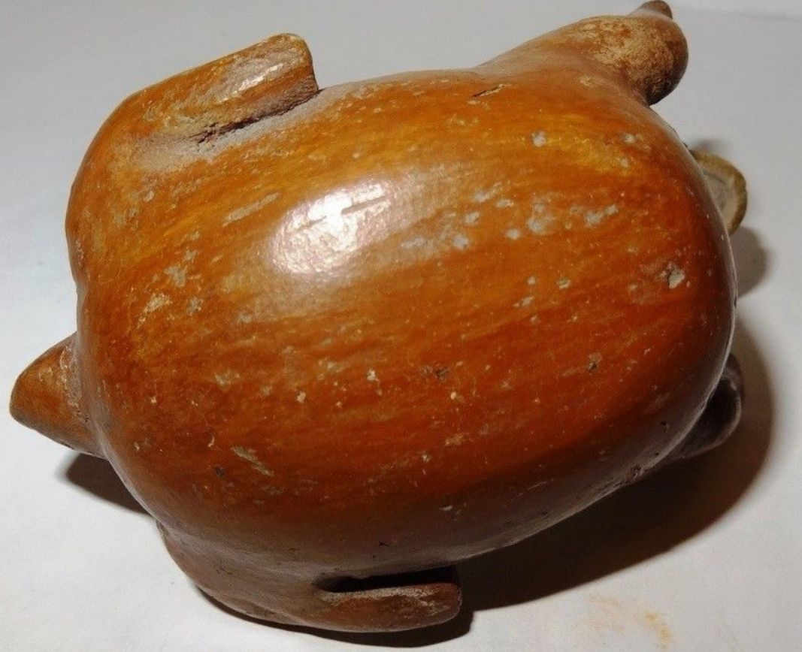 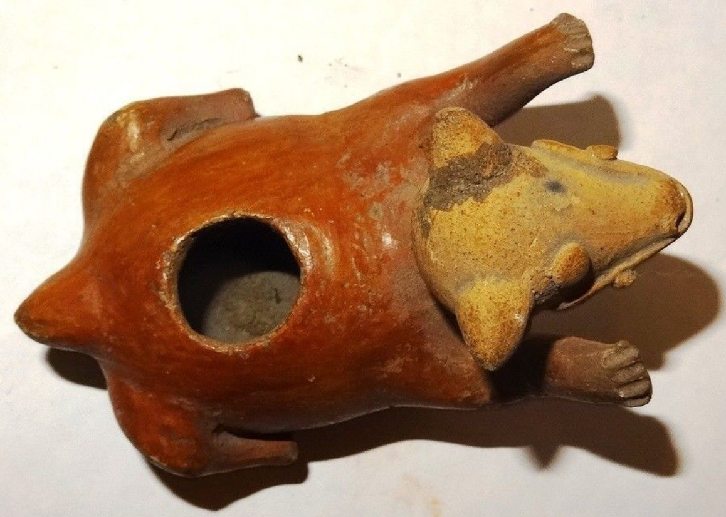

Figs. 1-8. Colima-Comala-Hairless Dog-Terracotta-Red Glaze-100-900 CE

**Case no.: 9**

**Accession Number:**

**Formal Label:** Colima-Comala-Hairless Dog-Terracotta-Red Glaze-100-900 CE

**Display Description:**

The Colima believed dogs were mythic emissaries of Xolotl, the Aztec god of the dead. The dog is the animal of the dead and therefore of the Place of Shadows (Spence 2015, p. 276). In the Mayan codices, the dog is associated with the god of death, storm, and lightning (Johnson 1994: 118).

Colima dogs were patterned after a hairless variety of ancient dog known as **Xoloitzcuintli,** from the god Xolotl and *itzcuīntli*, meaning “dog” in Nahuatl (*Nahuatl Dictionary* 1997). Xolotl, with his dog, were believed to be both guides of the Sun as it traveled through the underworld every night and guides of the spirits of the dead to their resting place in the underworld.

In life **Xoloitzcuintli** dogs are a tawny gray. They have been dated to at least 700 AD/CE when the Moche made ceramic figures of them. However, in myth they are a burnished vermilion as in this Colima terracotta ceramic, and their demeanors suggest they were considered as both a pet and a delicacy (which is implied by their often plump figures).

**LC Classification: F1219**

**Date or Time Horizon:** 100-900 CE

**Geographical Area:** Comala Site, west Mexico

Map:

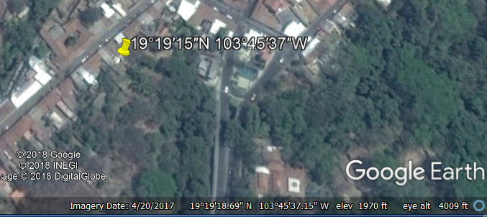

GPS: [19°19′15″N 103°45′37″W](https://tools.wmflabs.org/geohack/geohack.php?pagename=Comala&params=19_19_15_N_103_45_37_W_region:MX_type:city(20888))

**Cultural Affiliation:** Colima

**Medium:** terracotta

**Dimensions**: H 54 mm x L 85 mm

**Weight:**

**Condition: original**

**Provenance:** old French Collection. Nathalie Renaud, 62 route d'assevent 59131 Rousies, Nord-Pas-de-Calais, France métropolitaine

**Discussion:** TheLos Ortices era, which began around 500 BCE, witnessed the beginning of shaft tombs and a distinctive ceramic style called *rojo bruñido,* or burnished red. The Comala site (100 to 600 CE) perfected burnished red pottery with their most famous creation the hairless fattened dog.

The color red is a clue to their Mesoamerican mythological heritage as is seen in the Codex Borgia (p. 34, below). Within the sanctuary of the Red Temple, the Sun is finally born. A warrior drills a fire on the chest of a figure lying down with the solid red disk of the solar deity in the background. Immediately to the right, the deity is enthroned in his temple. He now has canine claws, a canine maw, the wind jewel, and a distended eye that identify him as the *red* Xolotl. As the solar guide, he now carries the Sun on his back (Boone 2013).

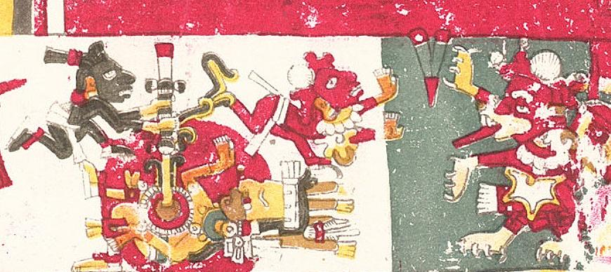

Xolotl is represented as a *red* dog, and is distinguished as the deity of air and of the four directions of the wind. His twin is Quetzalcoatl, and both are the sons of the virgin Coatlicue, the Aztec goddess who gave birth to the moon, stars, and Huitzilopochtli, the god of the Sun. Since twins in Mesoamerica were considered unnatural, one was usually sacrificed. The sacrificed twin in this case was Xolotl, portrayed as a dog, in the belief that dogs accompanied the souls of the dead to Mictlan, the underworld of Aztec mythology, while his surviving brother, Quetzalcoatl, “The Precious Surviving Twin,” dwells in the light of the Sun (Maffie 2013).

Pre-Hispanic period

[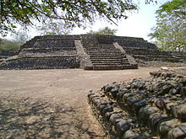](http://enacademic.com/pictures/enwiki/67/Campana_ed5.JPG)

Pyramid in La Campana

The state was home to a number of pre-Hispanic cultures as part of Western Mexico.[(](http://enacademic.com/dic.nsf/enwiki/142814#cite_note-conocolima-41) ["Conociendo Colima [Getting to know Colima]"](http://www.visitacolima.com.mx/Colima/colima.html) (in Spanish). Colima, Mexico: Secretaria de Turismo de Colima. <http://www.visitacolima.com.mx/Colima/colima.html>. Retrieved July 29, 2011.) Archeological evidencedates human occupation of the area as far back as 1500 BCE, with sites here con-temporary with San Lorenzo on the Gulf Coast and [Tlatilco](http://enacademic.com/dic.nsf/enwiki/2743029) in the [Valley of Mexico](http://enacademic.com/dic.nsf/enwiki/979345).

One period of the area’s development is called the Los Ortices era, which began around 500 BCE. During this time the elements which characterize the pre-Hispanic peoples of Colimaappear such as shaft tombs and a distinctive ceramic style called “rojo bruñido” or  burnished red. The next phase called Comala, covers the time period from around 100 to 600 CE, centered on a site of the same name. Comalapeople would perfect burnished red pottery and develop representations of people and animals with skill and fluidlines. The best known of these figures are known as the “fattened dogs”. The Comala site shows influence from[Teotihuacan](http://enacademic.com/dic.nsf/enwiki/49298). Around 500 CE, another site in Armería developed along the river of the same name (["Historia [History]"](http://www.inafed.gob.mx/work/templates/enciclo/Colima/) (in Spanish). Enciclopedia de los Municipios de México Colima. Mexico: Instituto Nacional para el Federalismo y el Desarrollo Municipal and Gobierno del Estado de Colima. 2005. <http://www.inafed.gob.mx/work/templates/enciclo/Colima/>. Retrieved July 29, 2011.)

**References:**

Boone, Elizabeth Hill (2007). Cycles of Time and Meaning in the Mexican Books of Fate. Austin: University of Texas Press.

Coe, Sophie D. (1994) *America's first cuisines.* Austin: University of Texas Press, 1994.

Johnson, Buffie (1994). Lady of the Beasts: The Goddess and Her Sacred Animals. Inner Traditions International.

Maffie, James (2015). Aztec Philosophy: Understanding a World in Motion. University Press of Colorado

Milbrath, Susan (2013). Heaven and Earth in Ancient Mexico: Astronomy and Seasonal Cycles in the Codex Borgia. Austin: University of Texas Press.

*Nahuatl Dictionary.* (1997). Wired Humanities Project. University of Oregon.

Reynolds, Richard. 1993. The ancient art of Colima, Mexico. Walnut Creek, CA : Squibob Press.



# Seler, Eduard (1904). Mexican And Central American Antiquities, Calendar Systems And History. translated by Charles P. Bowditch. Mexican and Central American Antiquities, Calendar System and History (Smithsonian Institution / Bureau of Ethnology, Bulletin No. 28) Washington: Government Printing Office.

# Appendix: AP 2